# CS 340 README

## About the Project/Project Title

The purpose of this web application is to provide a user-friendly interface to help sift through the animal data stored in our database. This database is powered by Mongo DB which can return desirable combinations of breed, gender, and age to be able to find specific dogs for different rescue needs. The project consists of a database, an API, and a dynamic dashboard.

## Motivation

This Project is to help me as a developer test my skills designing and implementing a script to update a database and use different languages to do so. This is also showing me how to use python testing files which will be advantageous for me to know going forward in my career and it also shows me how to persevere.

## Getting Started

To create a local copy of this program, you will need several steps. The first is to create a Mongo Database. The second is to program a Python CRUD module to access that database. The final step is to create a Dash web application that implements the Python CRUD module. This is a multi-layered application that reacts to changes in the table in real time.

Create a Mongo Database and create a database called AAC.

Create a user with read/write privileges to that AAC database.

Import the data from aac_shelter_outcomes.csv file

Run the CRUDjfoster file and then run the Dashboard ipbny python testing file

after you run that you will be able to see the dashboard presented and then will be able to sift through the data.

## Installation

This requires you to install the following

**MongoDB**

MongoDB comes in Community or Enterprise editions. Detailed instructions for the installation and downloading of MongoDB are available here: https://docs.mongodb.com/manual/installation/.

**Plotly**

Plotly must be imported in order to generate the proper charts. Plotly is a charting tool for Python applications and can be imported directly into your Python module from your Jupyter notebook. **Dash**

Dash is a framework used to build web applications. You can import the Dash Core Components into your Jupyter notebook and you can install Dash using the following information: https://pypi.org/project/dash/

## Usage:

This code has a couple of use cases with the first being used to sort data for a certain breed of dog to be able to have water based rescue. Using this Radio button you will be able to see all the dogs in the database that fall under that catagory. The next use is very similar but it used for Mountain recovery and these dog breeds are more acclimated for the mountain environment. The last pre-made filter is the Disaster recovery dog breeds which perform well at recovering people that have fallen under natural disasters. The other uses could be for filtering by breed type or filter by dog or cat.

### Code Example

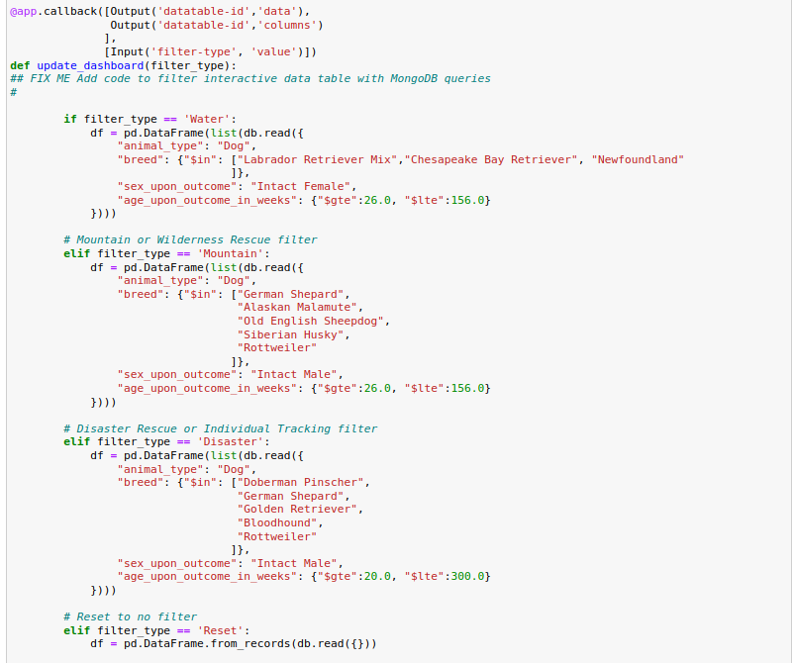

*This is an example of the radio buttons and their filters that they will present when used.*

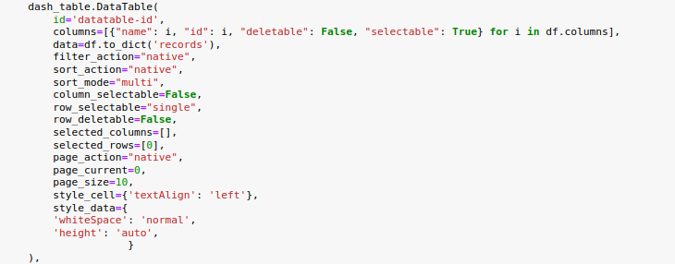

*This is an example of how the data table was formatted using Dash and html in dash*

### Screenshots

**

*Here is an example of the final product*

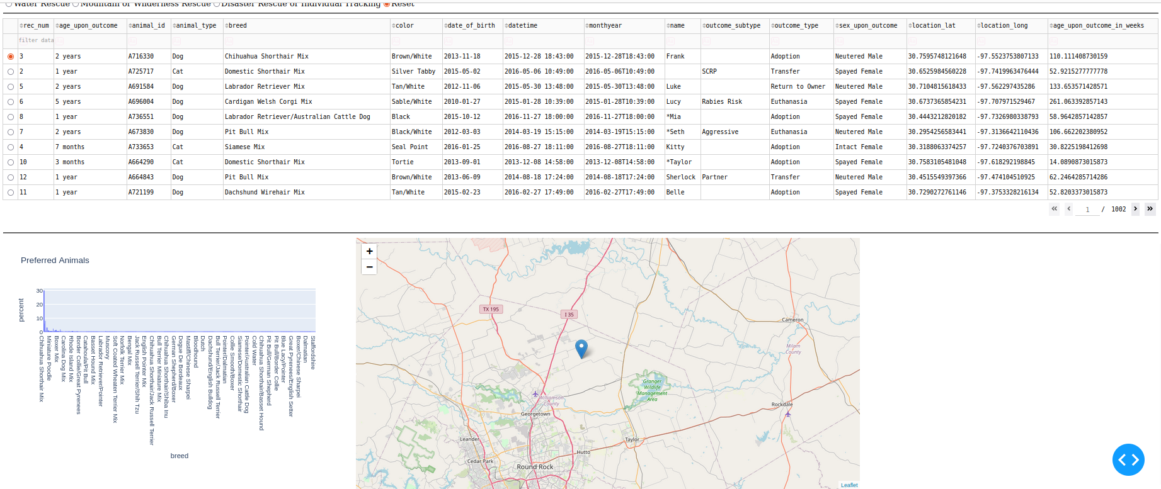

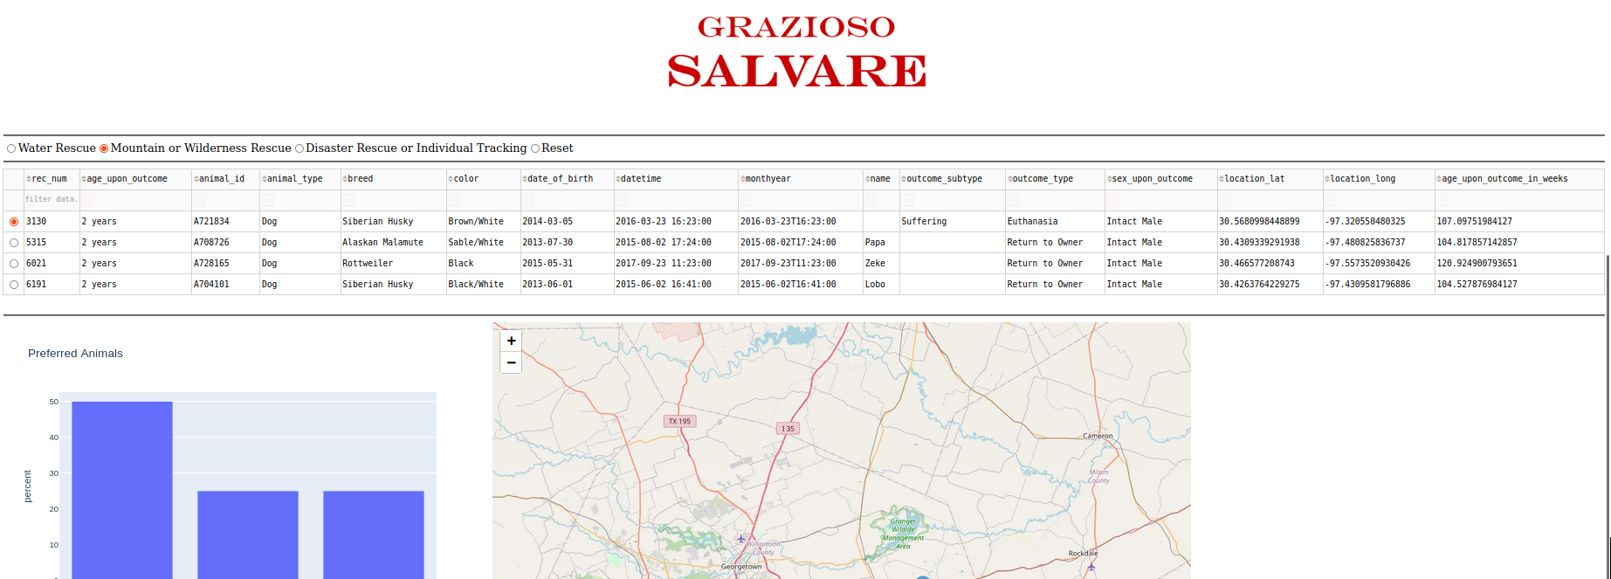

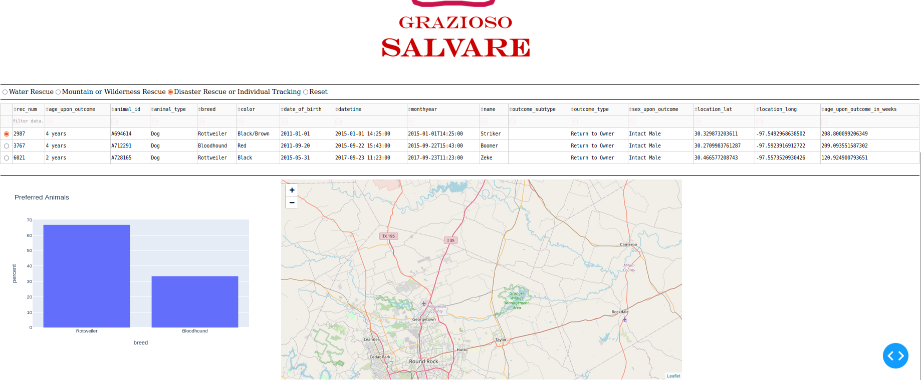

## Contact

Your name: Jackson Foster